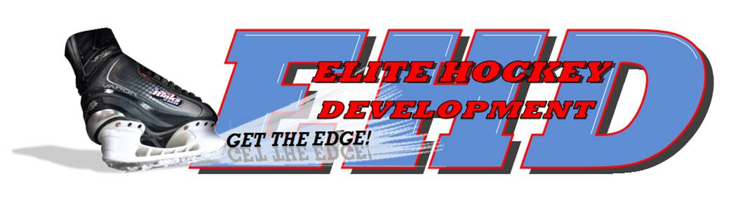
The EHD Checking and Battle Clinic is a 4 week program covering a wide range of checking skills and concepts including:
Body Checking Technique
Gap Control
Lateral Mobility
Angling/Mid Ice Engagement
Skating/Edge Control
Denying Passing Lanes
Reading Pressure Points
Supporting Your Partner
Net Front Play
Initiating Body Contact
Receiving Body Contact
Awareness and Respect
Small Area Battle Drills
And Many More Tricks of the Trade!

Body contact is a key part of this fast and physical game. To be able to perform at the highest level of your ability, it is crucial to be able to give and receive body contact, while reducing the risk of injury.

We look forward to improving each player’s confidence and abilities when giving and receiving body contact!

This camp is open to players born in 2005, 2004 and 2003

Cost: $125.00
Tuesday Nights April 4,11,18,25
6:30pm-7:20pm
24 Player Maximum

Call 603-775-7423 to enroll!

